CSC 3210

Computer Organization and Programming

Lab 9

Answer Sheet

Student Name: **Rafid Shaon**

Section: 06 / CRN: 18119 - Bikram

Lab 9(a)

Debug through each line of instructions.

Take screenshot that includes code and register window.

Record the register content.

**and explain the register contents or memory contents.**

Code:

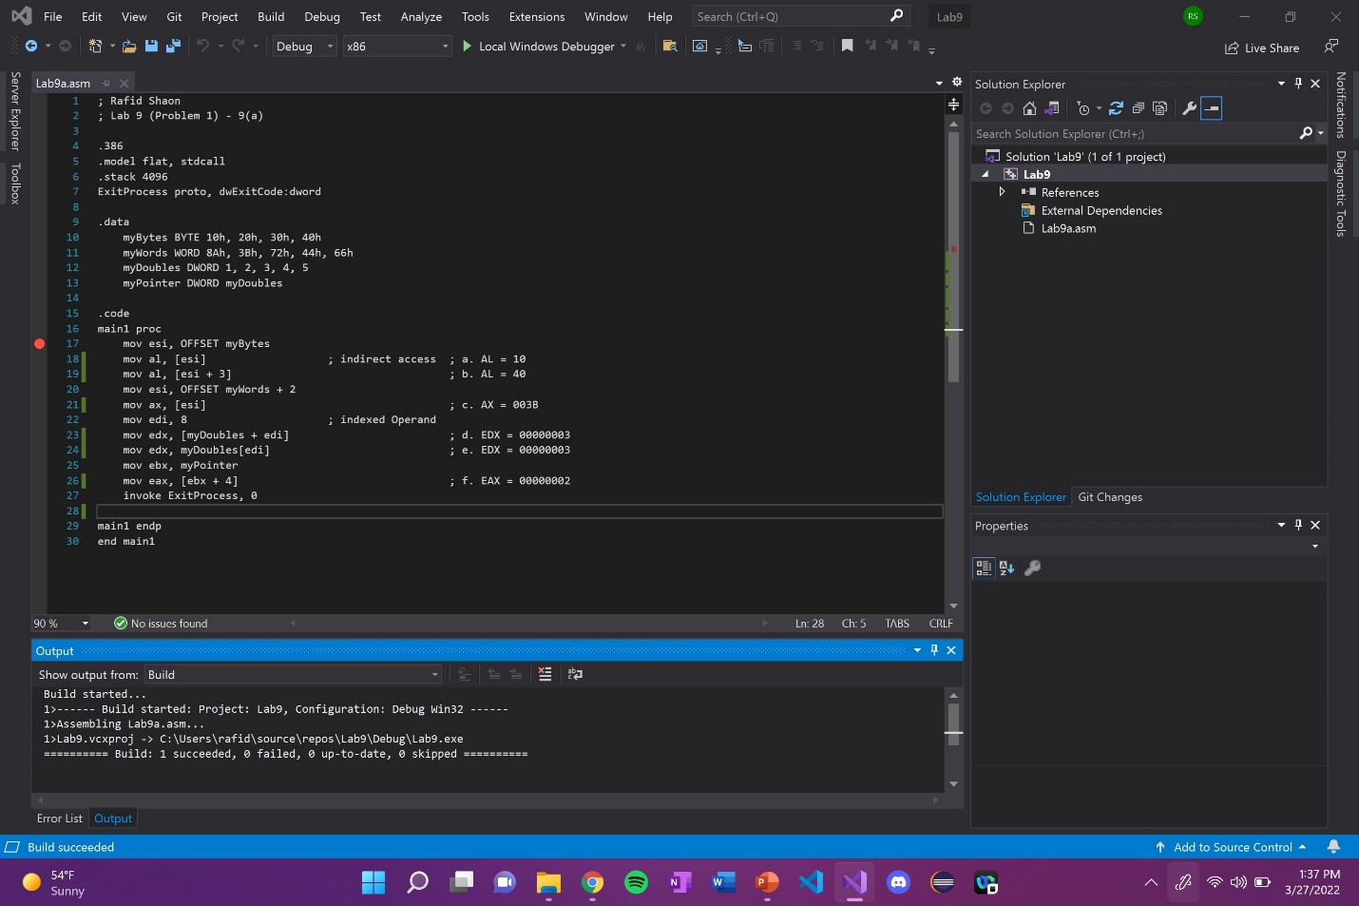

Line number: 17

Instruction: mov esi, OFFSET myBytes

Register values: ESI = 00ED4000

Screenshot: 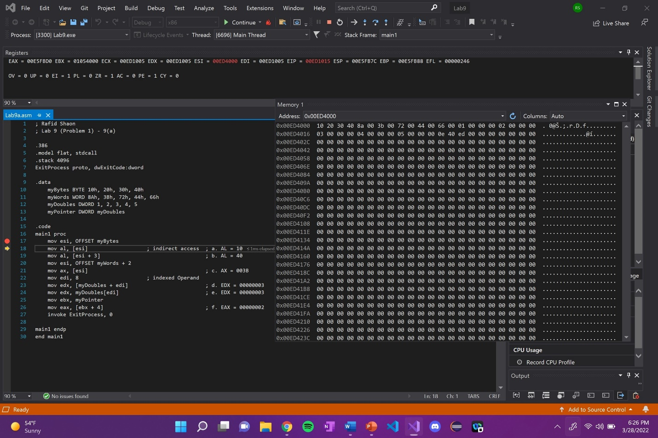

Explanation: N/A

Line number: 18

Instruction: mov al, [esi]

Register values: EAX = 0035FB10

Screenshot: 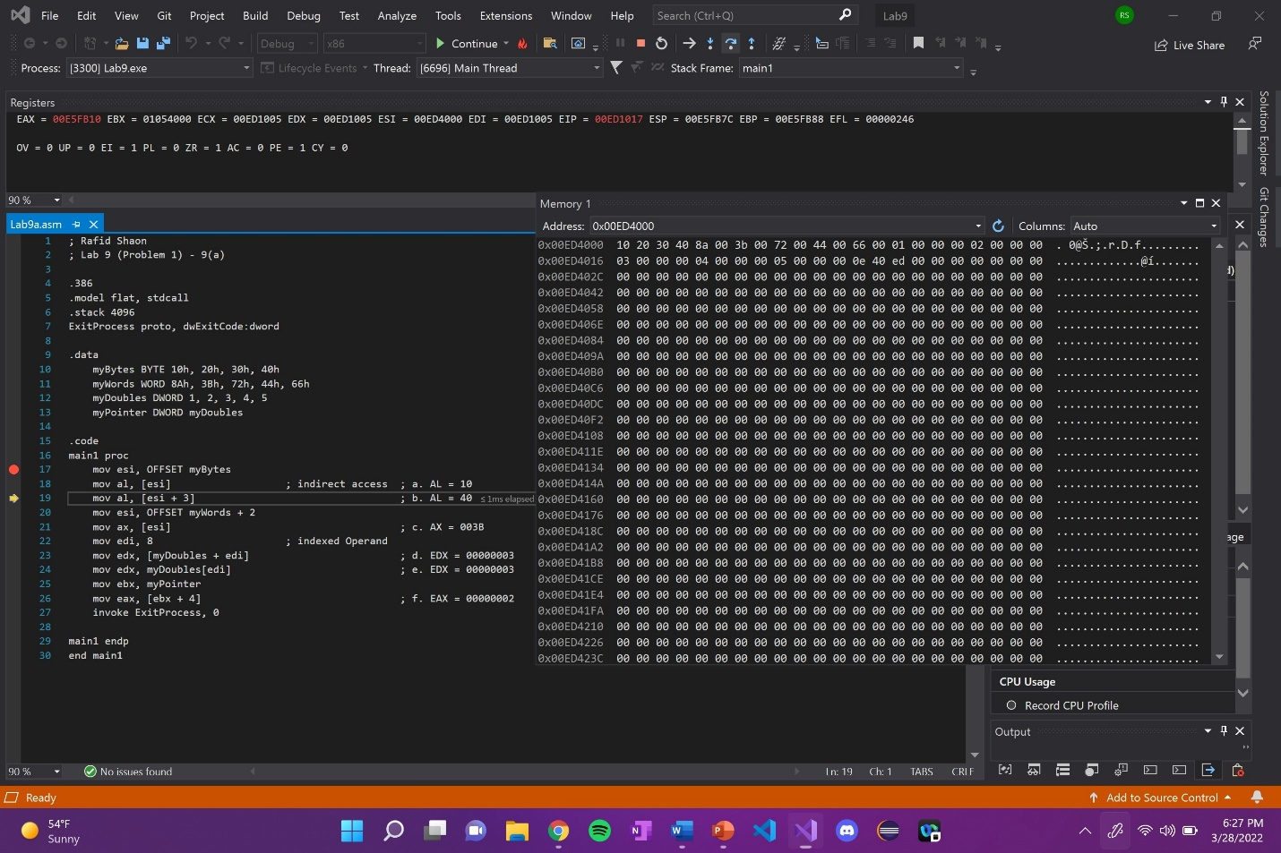

Explanation: EAX register is 32-bit long with a signed integer variable. The register is updated

with 10 when the first element in ESI is moved to AL.

Line number: 19

Instruction: mov al, [esi + 3]

Register values: EAX = 00E5FB40

Screenshot: 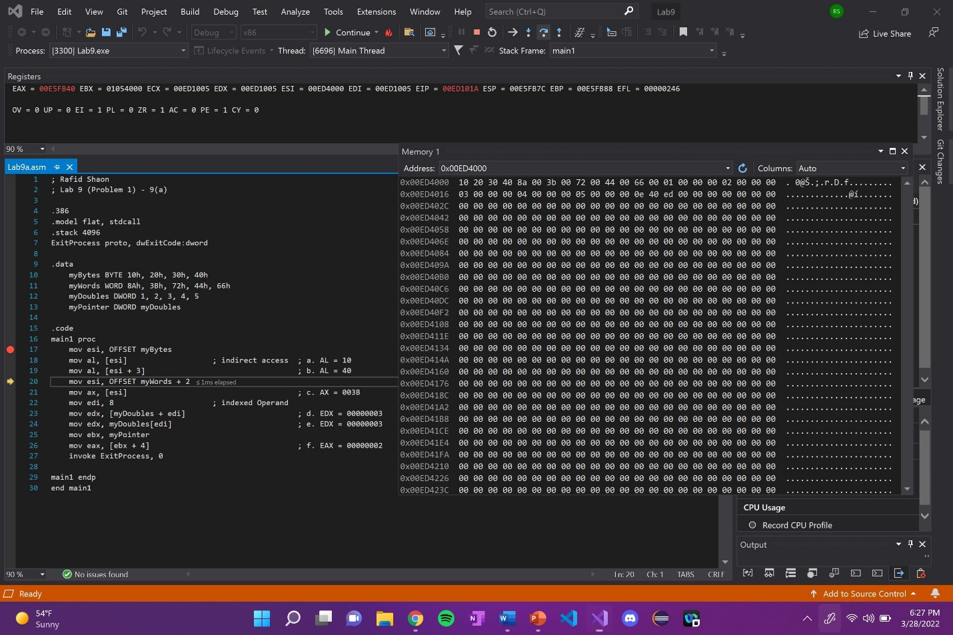

Explanation: EAX register is updated with 00E5FB40. Just like the line 18, this time [ESI + 3] element is moved to AL.

Line number: 20

Instruction: mov esi, OFFSET myWords + 2

Register values: ESI = 00ED4006

Screenshot: 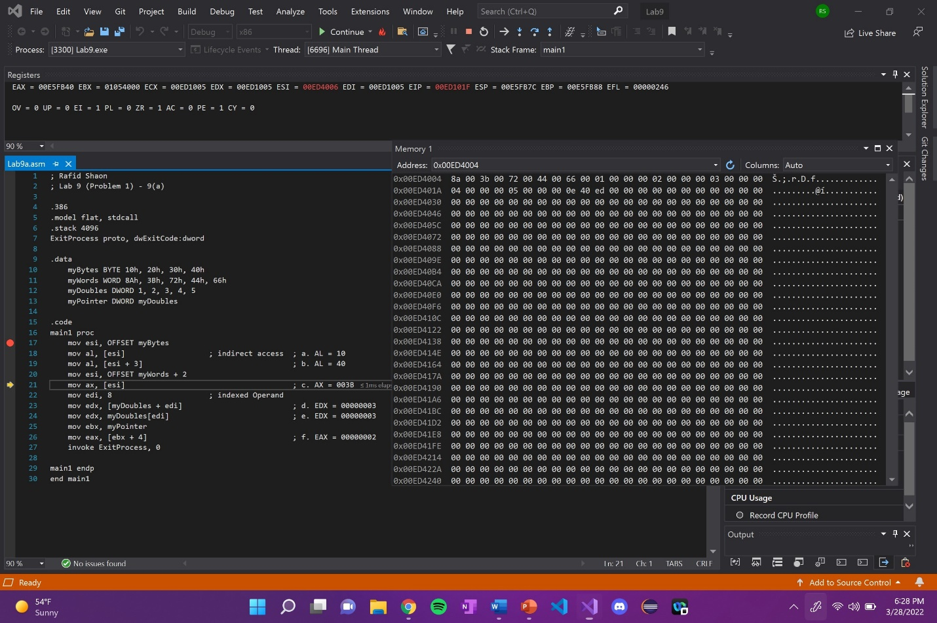

Explanation: N/A

Line number: 21

Instruction: mov ax, [esi]

Register values: EAX = 00E5003B

Screenshot: 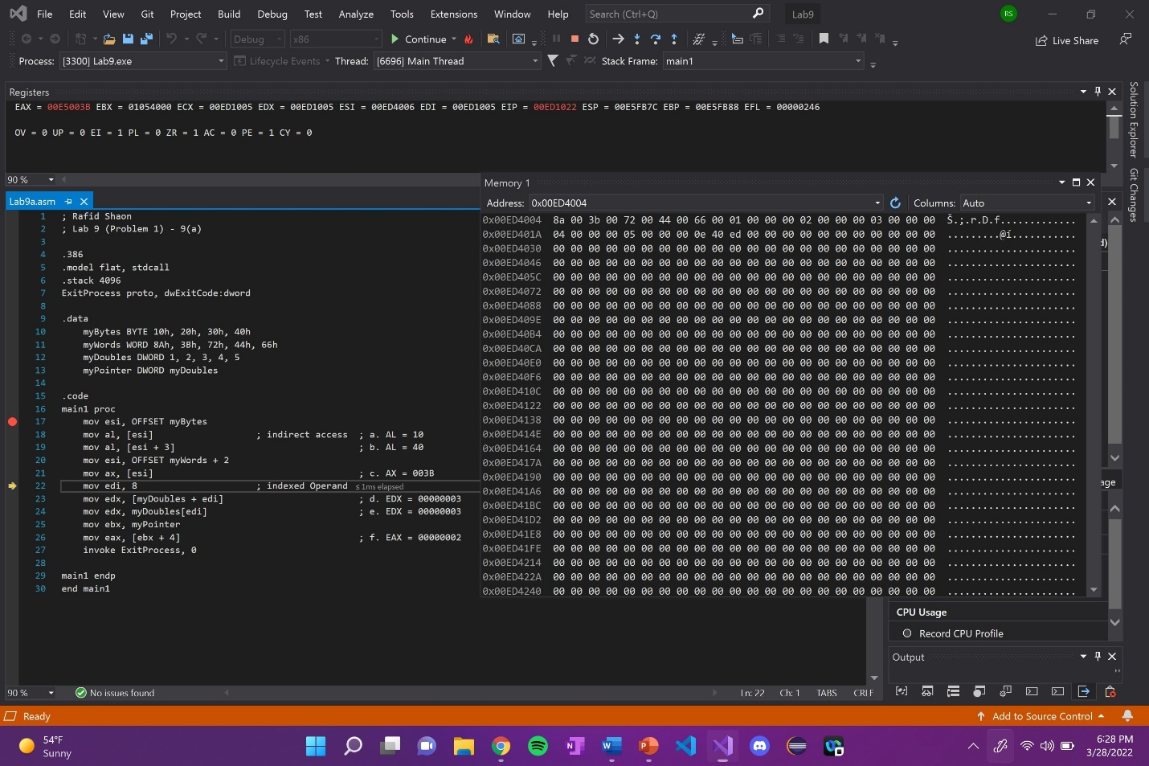

Explanation: EAX register is updated with 003B in ax when [ESI] is moved to AX.

Line number: 22

Instruction: mov edi, 8

Register values: EDI = 00000008

Screenshot: 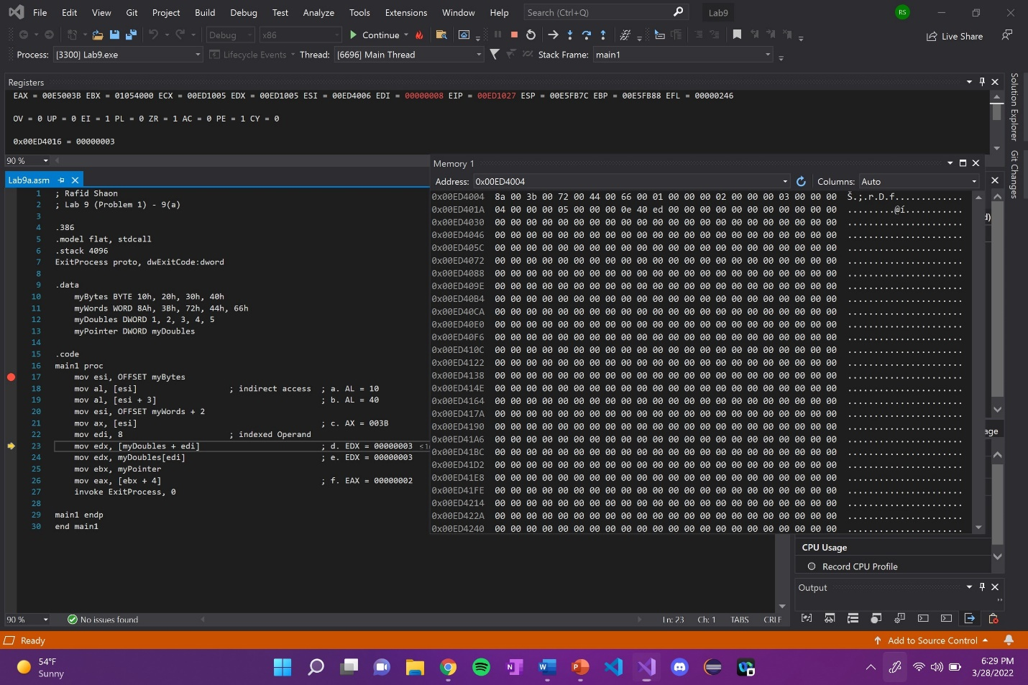

Explanation: Just an update of 8 into the EDI.

Line number: 23

Instruction: mov edx, [myDoubles + edi]

Register values: EDX = 00000003

Screenshot: 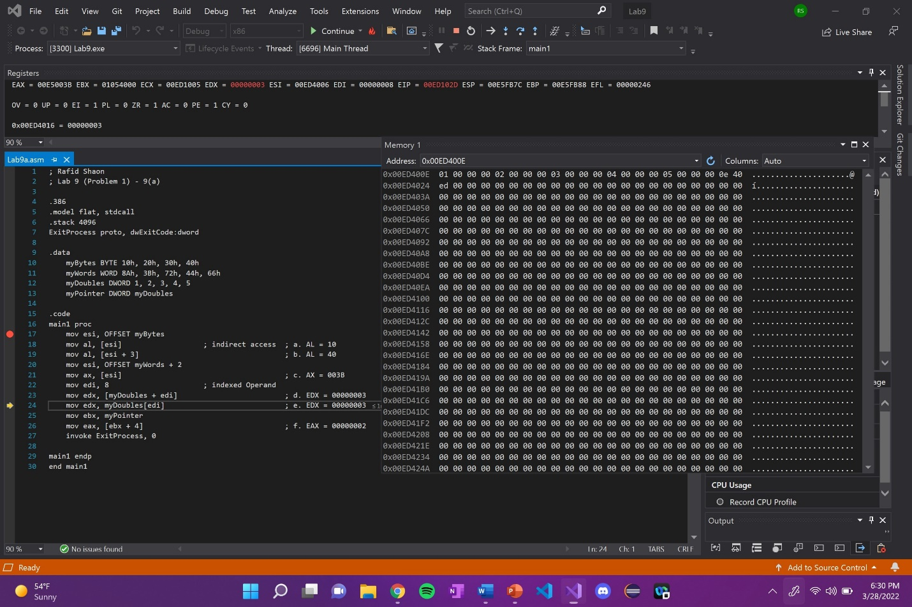

Explanation: EDX register is updated with 00000003 when [myDoubles + EDI] is moved to EDX.

Line number: 24

Instruction: mov edx, myDoubles[edi]

Register values: EDX = 00000003

Screenshot: 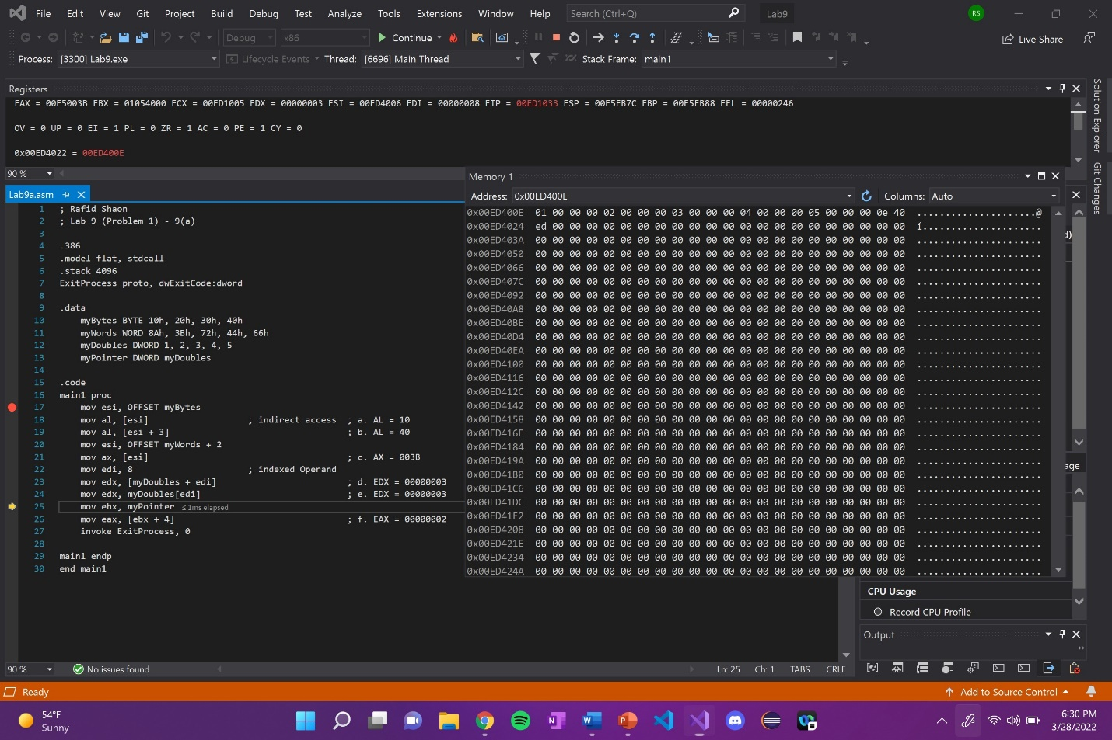

Explanation: No change in the EDX register, but you can see a memory update 0x00ED4022 = 00ED400E.

Line number: 25

Instruction: mov ebx, myPointer

Register values: EBX = 00ED400E

Screenshot: 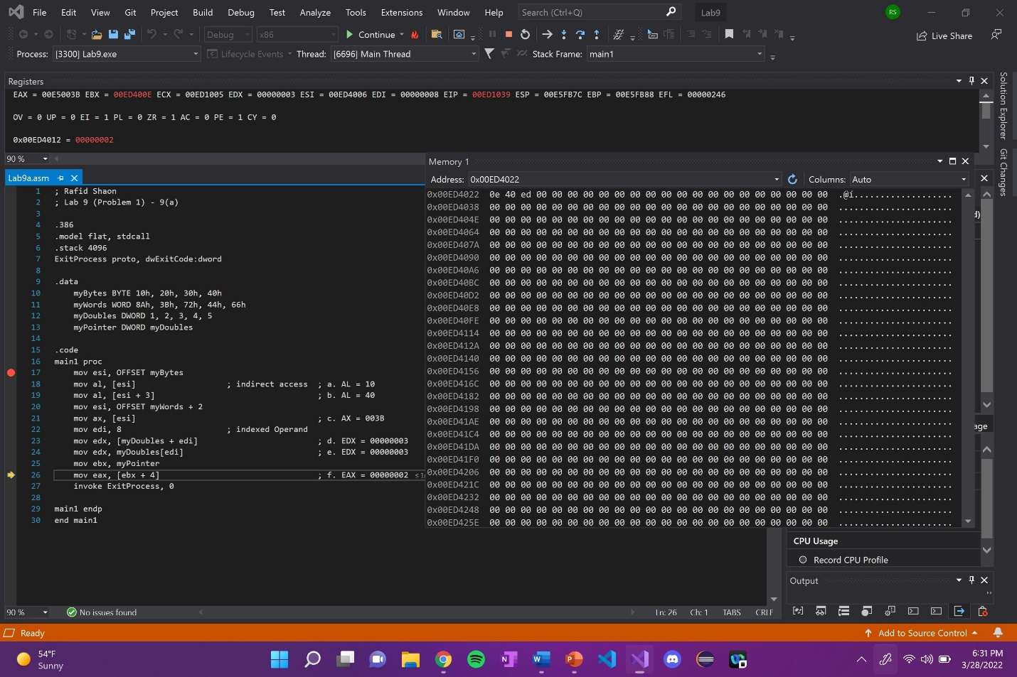

Explanation: EBX register is 32-bit long with a signed integer variable. The register is updated

with 00ED400E when the elements in myPointer memory is moved to EBX.

Line number: 26

Instruction: mov eax, [ebx + 4]

Register values: EAX = 00000002

Screenshot: 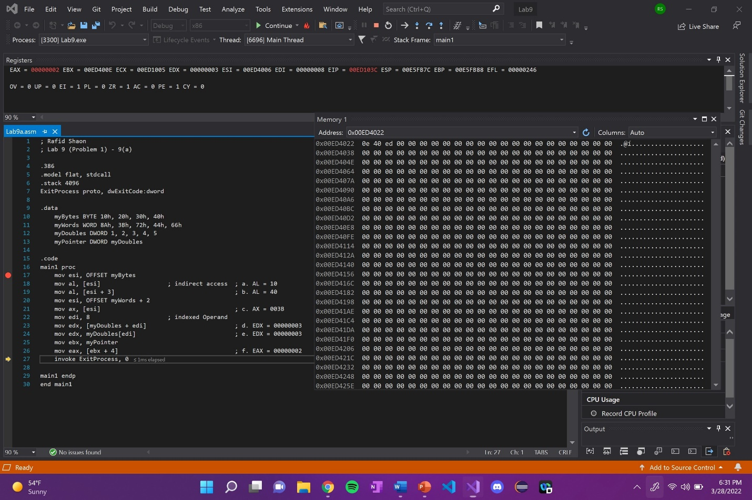

Explanation: EAX register is 32-bit long with a signed integer variable. The register is updated

with 00000002 when [EBX + 4] is moved to EAX.

(Copy this format as needed)

Lab 9(b)

Debug until you reach “INVOKE ExitProcess, 0”.

Take a screenshot of the code and register window at the end

Record the content of the EAX register

**Then explain the register content.**

Code: 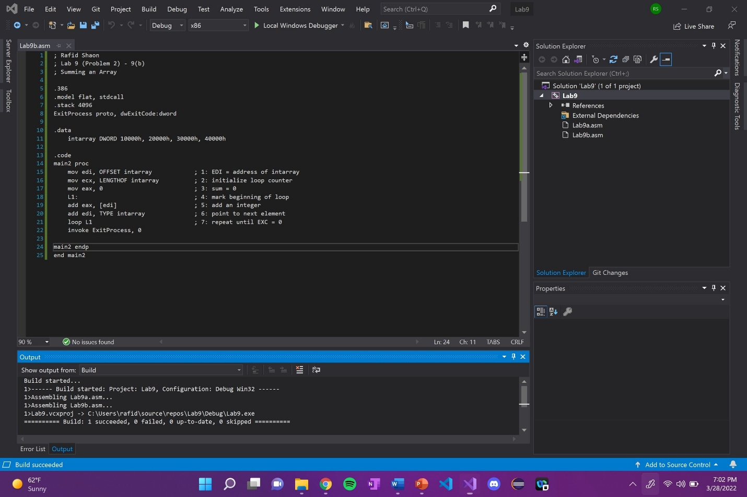

EAX Register value: EAX = 000A0000

Screenshot: 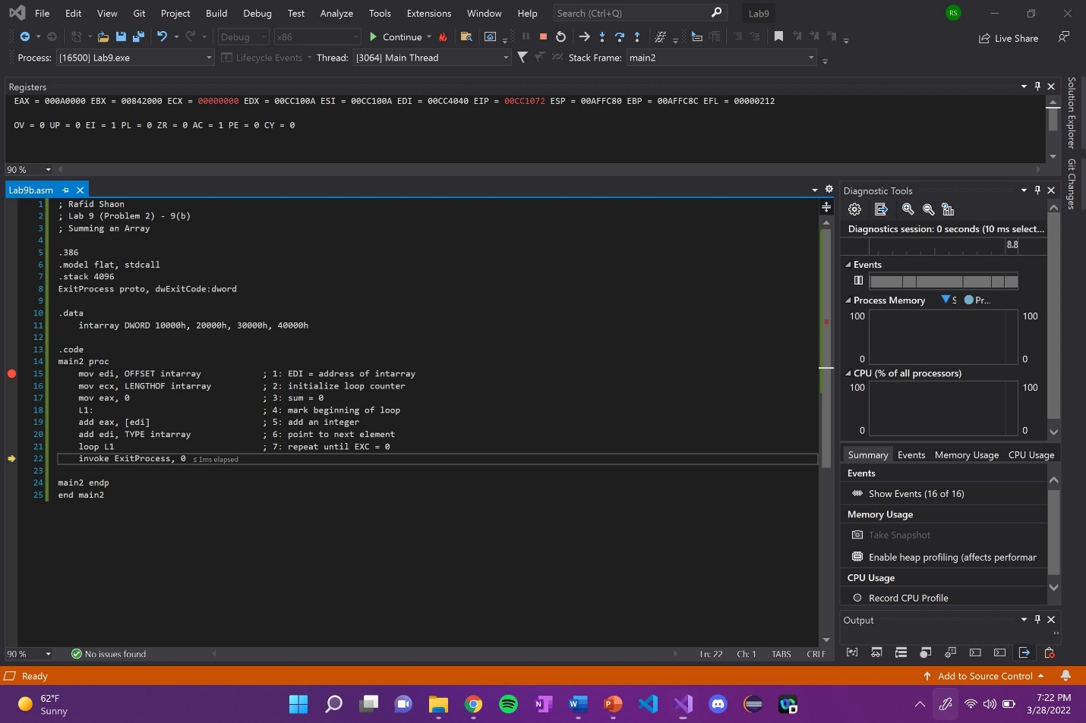Explanation: ECX will be updated to the next iteration after line 18 until ECX = 0

Since lines 19, 20, and 21 are in the loop L1, it will continue to add the next value to EAX from EDI and point to the next element in intarray

- EAX = 00010000 EDI = 00CC4034 ECX = 00000004

- EAX = 00030000 EDI = 00CC4038 ECX = 00000003

- EAX = 00060000 EDI = 00CC403C ECX = 00000002

- EAX = 000A0000 EDI = 00CC4040 ECX = 00000001

- EAX = 000A0000 EDI = 00CC4040 ECX = 00000000

Lab 9(c)

Debug until you reach “INVOKE ExitProcess, 0”.

Take a screenshot of the code and register window at the end

Record the content of the EAX register

**Then explain the register content.**

Code: 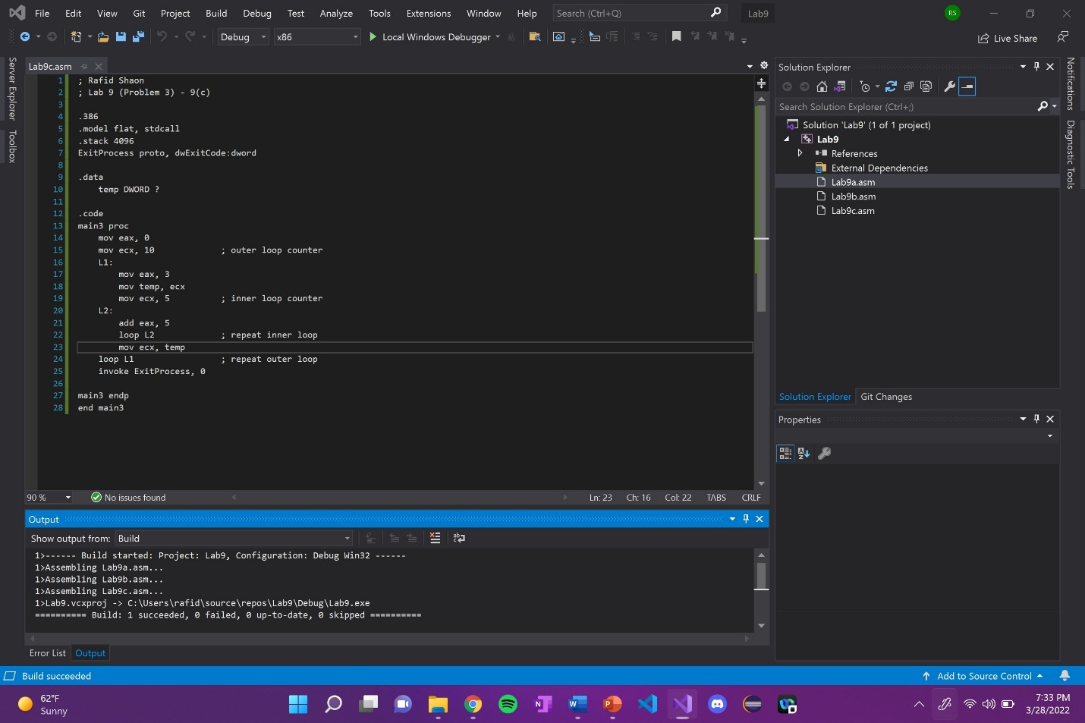

EAX Register value: EAX = 0000001C

Screenshot: 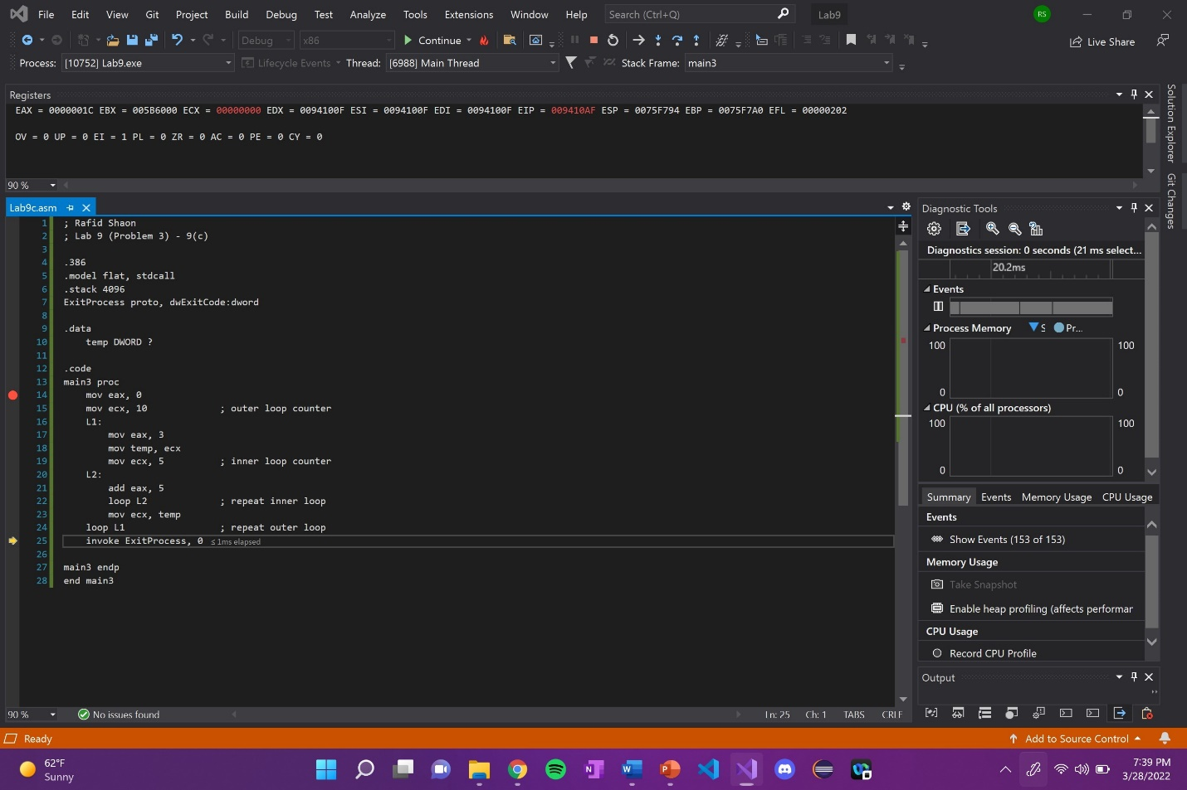

Explanation: This program never stops running. The results of the outer loop (L1) decrements ECX to zero and the inner loop (L2) decrements ECX to FFFFFFFFh. This will then cause the outer loop (L1) to repeat again, hence the program continuously running.

Lab 9(d)

Debug through each line of instructions.

Take screenshot that includes code and register window.

Record the register content.

**and explain the register contents or memory contents.**

Code: 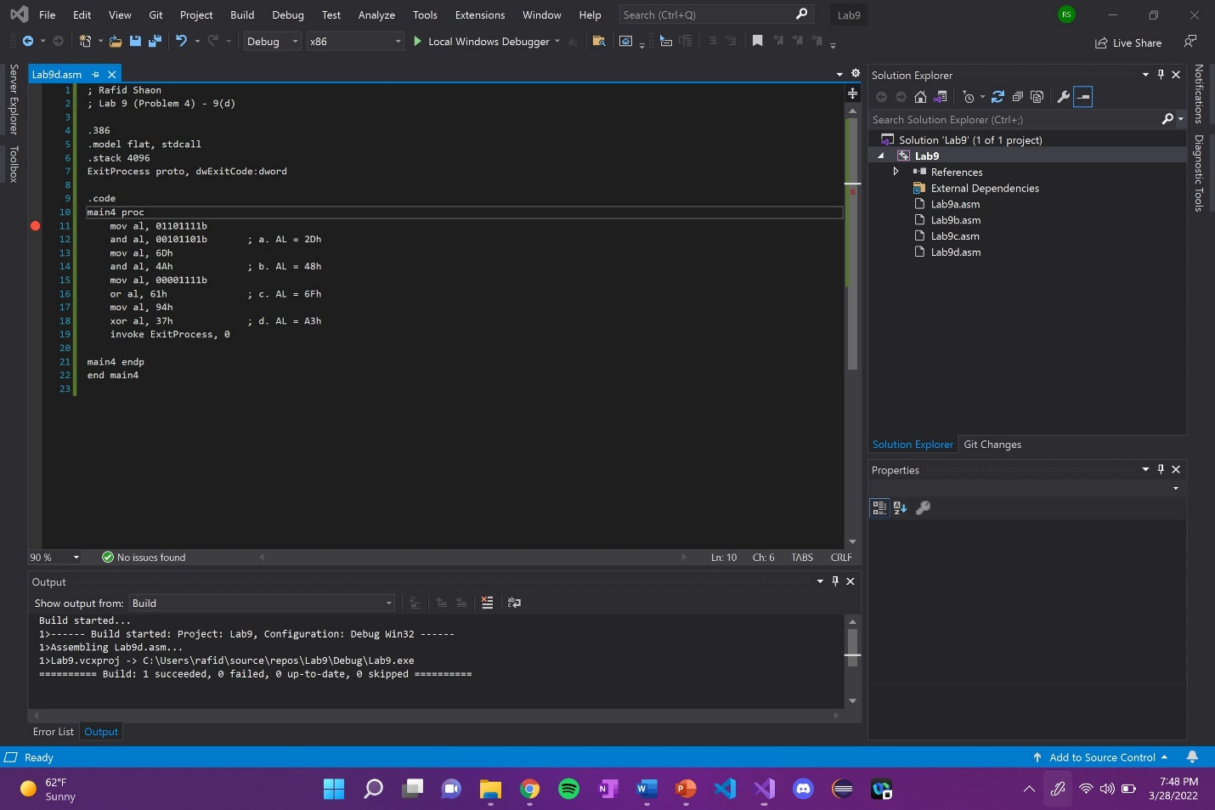

Line number: 11

Instruction: mov al, 01101111b

Register values: EAX = 00BAFB**6F**

Screenshot: 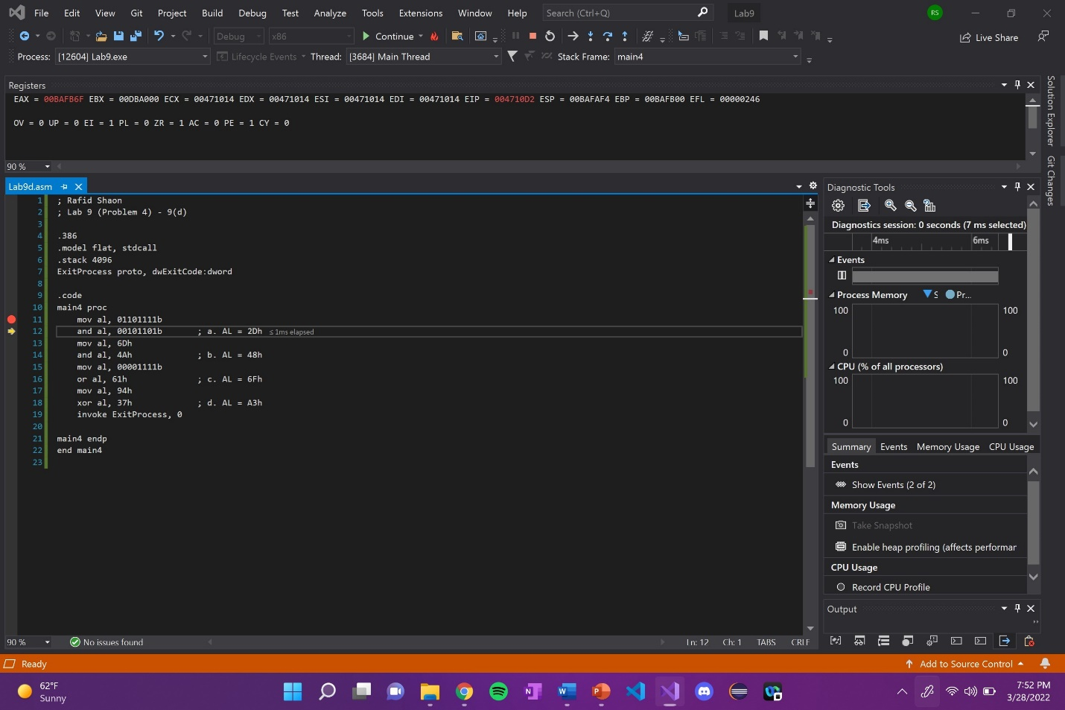

Explanation: AL in EAX register is updated with 01101111b (6Fh).

Line number: 12

Instruction: and al, 00101101b

Register values: EAX = 00BAFB**2D**

Screenshot: 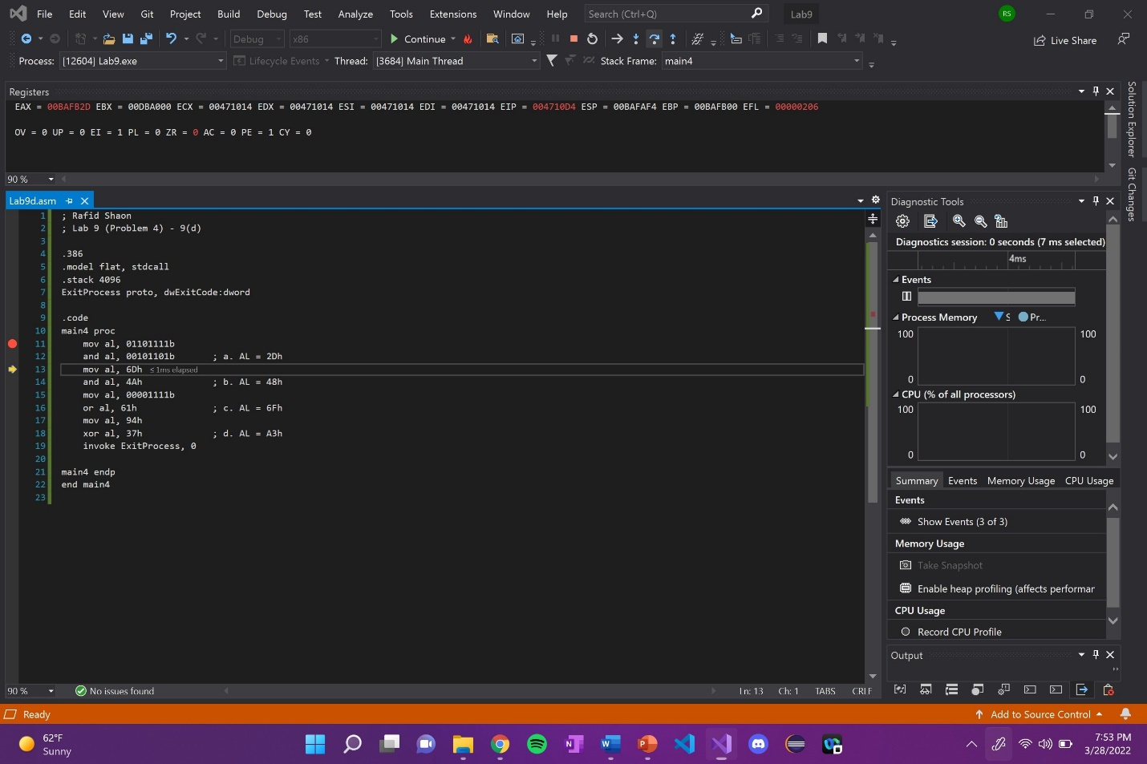

Explanation: AL in EAX register is updated with 2Dh (00101101b).

01101111b (6Fh) ^ 00101101b (2Dh) -> 00101101b (2Dh).

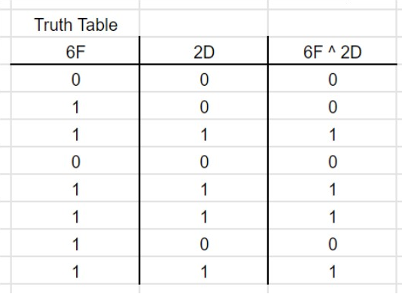

Line number: 13

Instruction: mov al, 6Dh

Register values: EAX = 00BAFB**6D**

Screenshot: 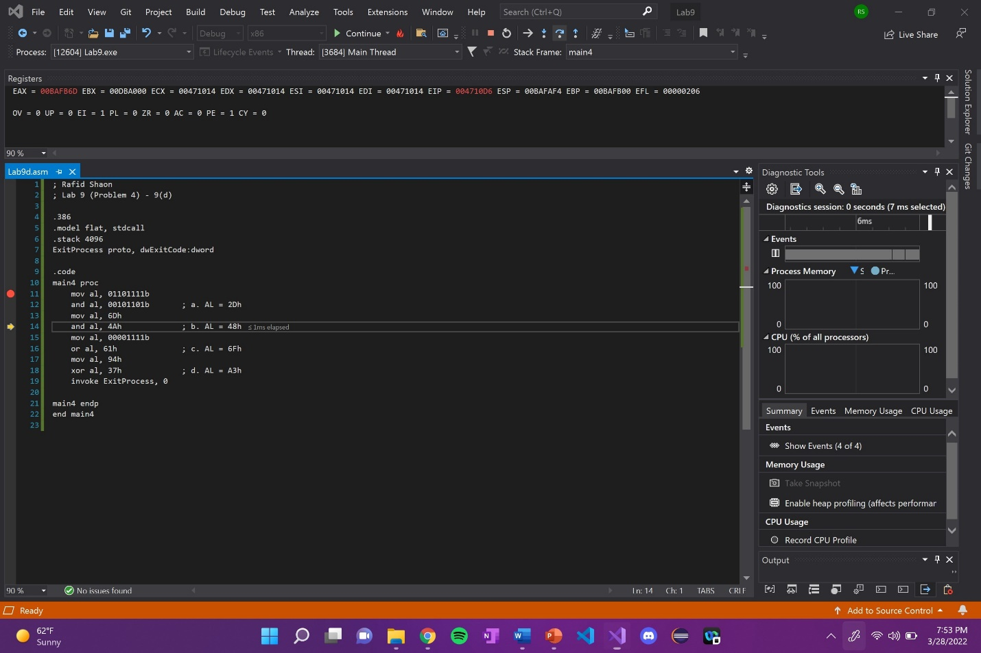

Explanation: AL in EAX register is updated with 6Dh.

Line number: 14

Instruction: and al, 4Ah

Register values: EAX = 00BAFB**48**

Screenshot: 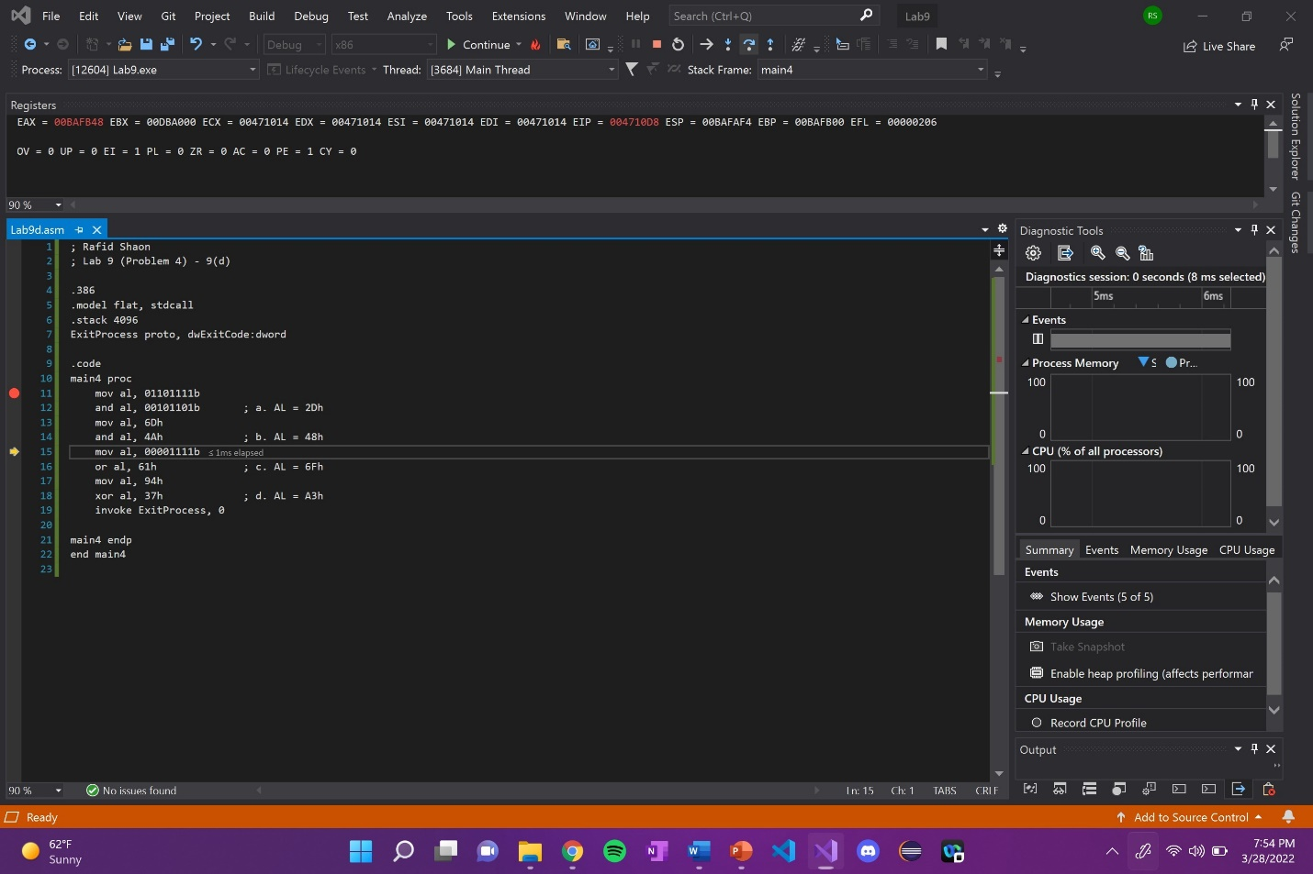

Explanation: AL in EAX register is updated with 48h (01001000b).

6Dh (01101101b) ^ 4Ah (01001010b) -> 48h (01001000).

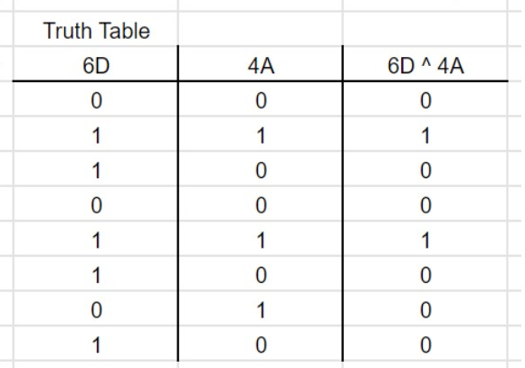

Line number: 15

Instruction: mov al, 00001111b

Register values: EAX = 00BAFB**0F**

Screenshot: 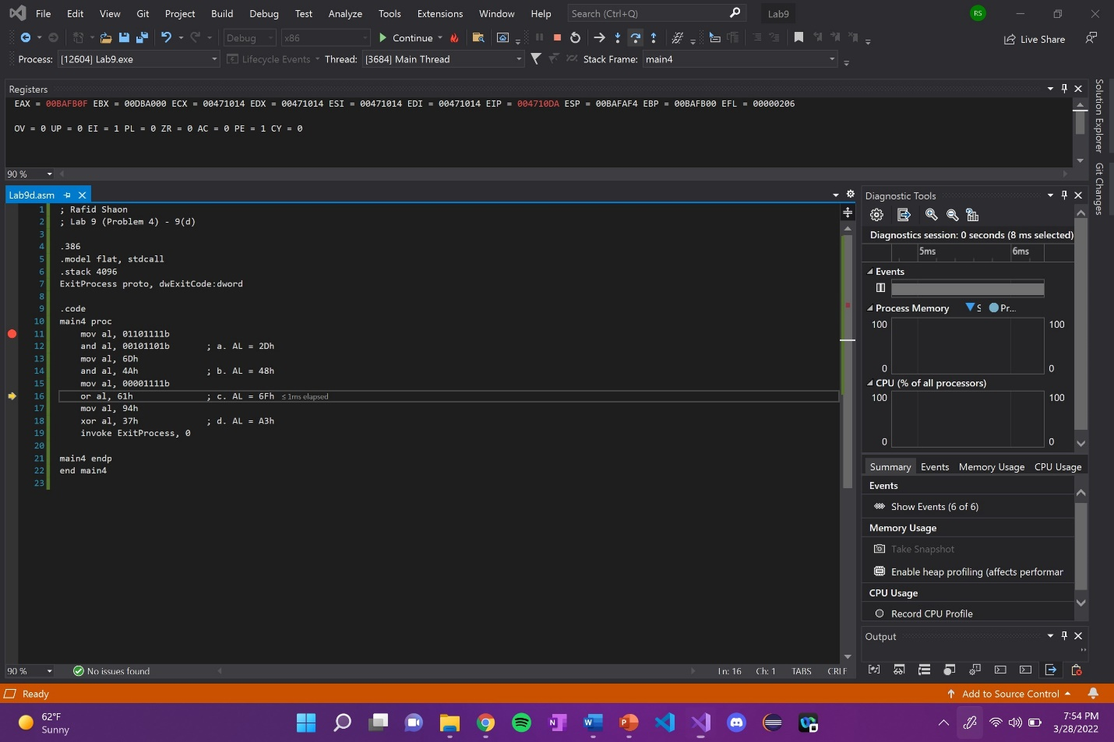

Explanation: AL in EAX register is updated with 00001111b (0Fh).

Line number: 16

Instruction: or al, 61h

Register values: EAX = 00BAFB**6F**

Screenshot: 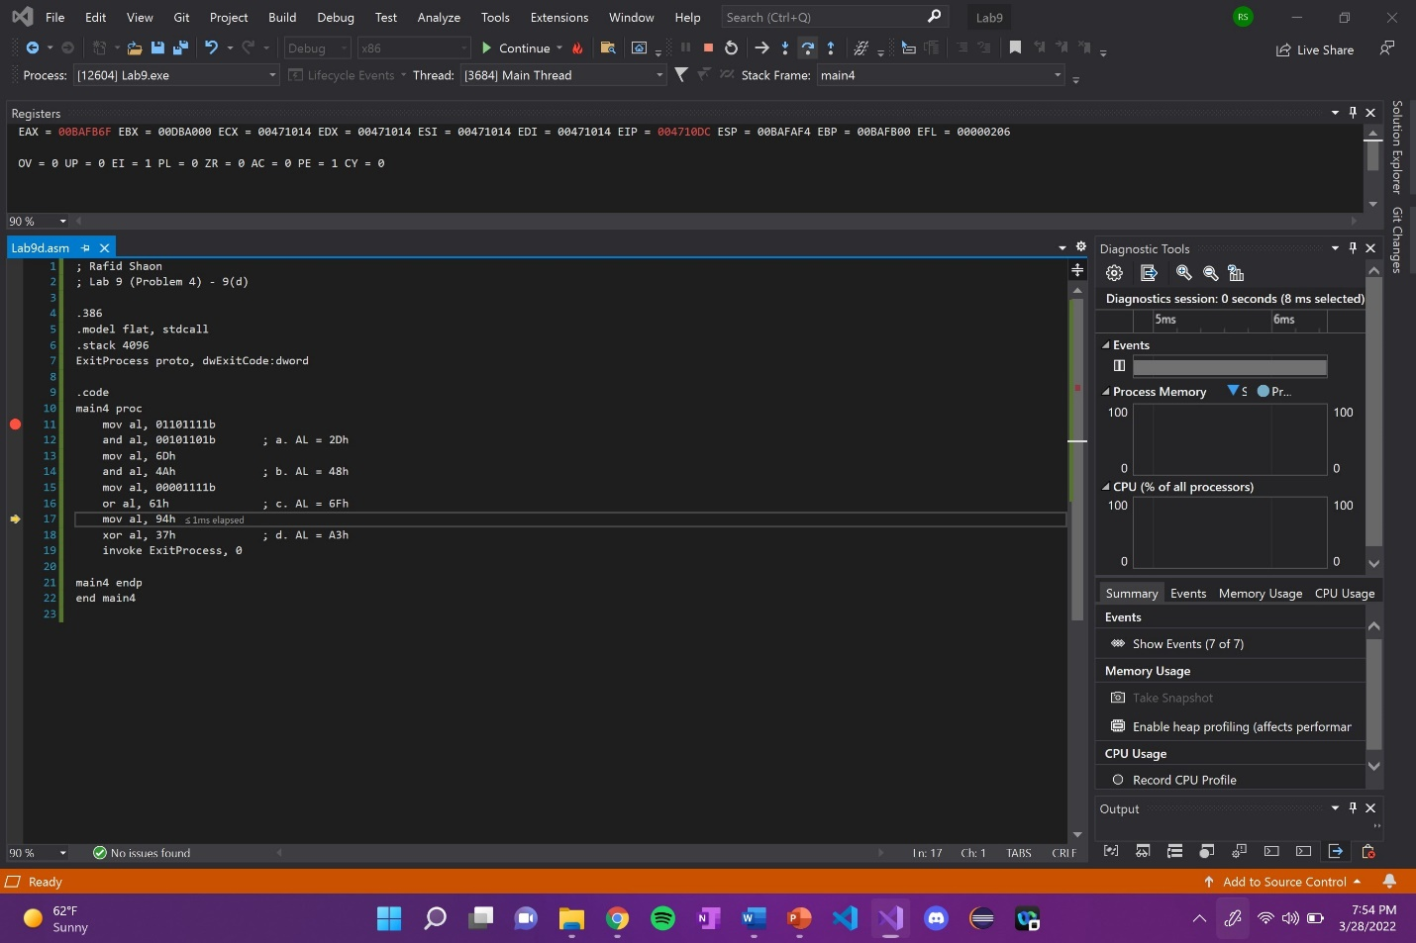

Explanation: AL in EAX register is updated with 6Fh (01101111b).

0Fh (00001111b) v 61h (01100001b) -> 6Fh (01101111b).

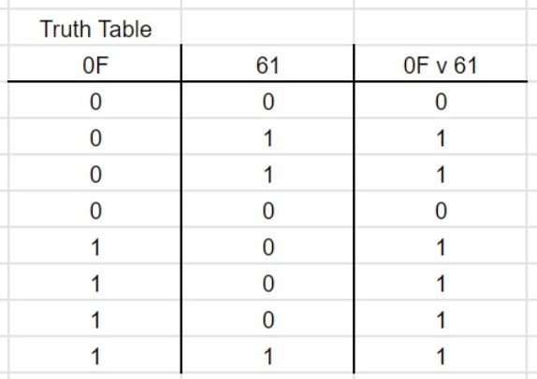

Line number: 17

Instruction: mov al, 94h

Register values: EAX = 00BAFB**94**

Screenshot: 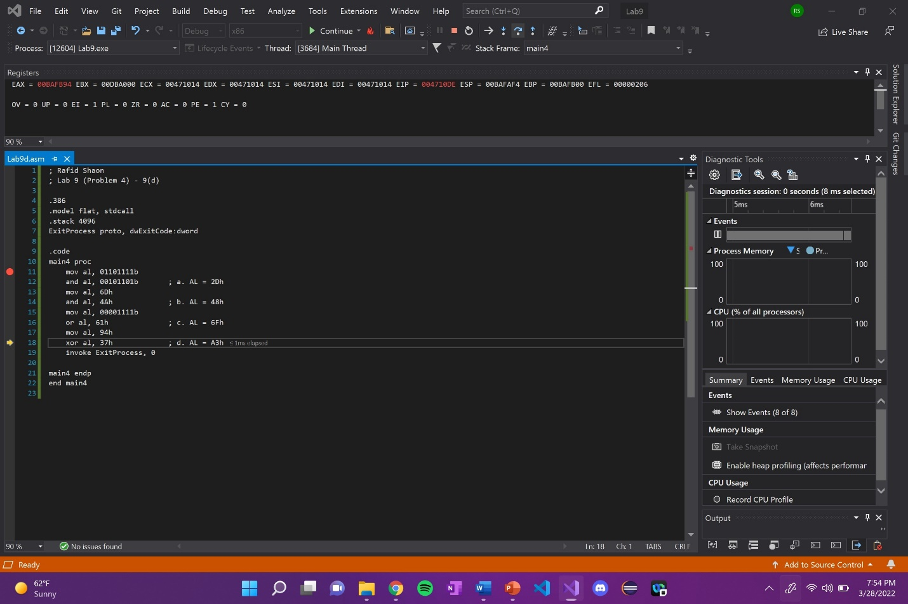

Explanation: AL in EAX register is updated with 94h.

Line number: 18

Instruction: xor al, 37h

Register values: EAX = 00BAFB**A3**

Screenshot: 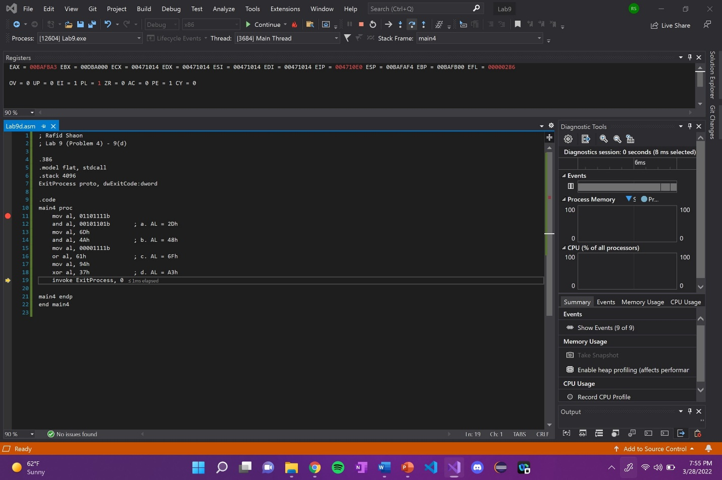

Explanation: AL in EAX register is updated with A3h (10100011b).

94h (10010100b) xor 37h (00110111b) -> A3h (10100011b).

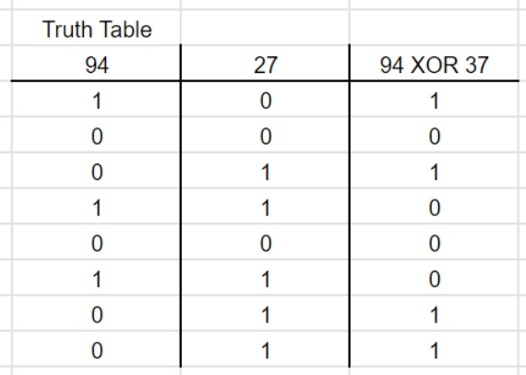

(Copy this format as needed)